
Department of Engineering Technology
Foundation University Islamabad
School of Science and Technology
Mid lab report
Name: tooba jamil
Roll no: BSIET-Fall/24-046

Performance |  |  | Lab Report
Description | Total  Marks | Marks Obtained | Description | Total  Marks | Marks Obtained
Problem Understanding | 5 |  | Communication | 5
Code writing | 5
Total Marks obtained
Remarks (if any): ………………………………….
Name & Signature of faculty: ……………………………

1. Introduction
This lab report documents the design and development of a Student Task Manager Web Application built as part of the Mid Term Examination for the Introduction to Web Technologies Lab .The application is a fully functional, single-page web app that enables students to manage their academic assignments efficiently.
The application covers all five parts of the exam question:
- Part a :Semantic HTML structure with a task input form and display table
- Part b : Responsive CSS using Flexbox/Grid, box model, and media queries
- Part c :JavaScript with ES6 features, DOM manipulation, and event handling
- Part d : API integration using Fetch API with JSONPlaceholder (fake/mock)
- Part e : Filter by subject and sort by due date

2. Application Development Process

2.1 Part (a) Semantic HTML Structure
The page is structured using semantic HTML5 elements to ensure accessibility and clarity:
- <header> Contains the application title and branding badge
- <main> Wraps the grid layout with two columns
- <aside> Left column hosting the form and API section
- <section> Right column containing the task table and controls
- <form id="taskForm"> Contains labelled inputs for Task Name, Subject, and Due Date
- <table> Used with <thead>, <tbody>, <th>, <td> for structured task display
The form includes three inputs: a text field for the task name, a <select> dropdown for subject, and an <input type="date"> for the due date, plus a submit button.

2.2 Part (b) CSS Styling & Responsiveness
A dark-themed design was applied using CSS custom properties (variables) to maintain visual consistency. Key CSS techniques used:
- Box Model: margin, padding, and border are explicitly set on all cards and form elements using rem and px units
- Flexbox: Used in header (row alignment), controls bar (flex-wrap), and API item layout
- CSS Grid: main uses grid-template-columns: 360px 1fr for a two-column layout
- Media Queries: At max-width: 768px, the grid collapses to a single column and controls stack vertically. At max-width: 480px, the header badge is hidden to save space
- UI Design Principles: Consistent spacing with gap and padding, readable font sizes, and color-coded subject pills for visual differentiation

2.3 Part (c) JavaScript & ES6 Features
JavaScript was used to make the application fully interactive. The following ES6 features were explicitly used:
ES6 Feature | Usage in Code
Arrow Functions | renderTasks, deleteTask, fetchAPIData all defined as const fn = () => {}
Destructuring | const { value: taskName } = document.getElementById('taskName')
Spread Operator | tasks = [...tasks, newTask] immutable array update
Template Literals | Building HTML strings with ${} interpolation inside map()
async / await | fetchAPIData() is an async function using await fetch(...)
const / let | All variables use block-scoped const and let

Form submission is handled with addEventListener('submit', ...) to prevent default page reload. Tasks are stored in a let tasks = [] array and re-rendered on every state change by calling renderTasks(), which reads from the live array.

2.4 Part (d) API Integration
The JSONPlaceholder API (https://jsonplaceholder.typicode.com/todos?_limit=5) was used as the fake/mock API. The integration works as follows:
- The user clicks the 'Fetch from API' button
- A loading animation (bouncing dots) is displayed while the request is in progress
- The Fetch API sends a GET request using async/await
- On success, five todo items are rendered as styled cards with title, user ID, and a status badge (To Do / In Progress / Done) derived from the item ID
- Errors are caught with try/catch and an error message is shown to the user

2.5 Part (e) Filter & Sort
Both filter and sort are implemented as reactive controls — they re-render the task table immediately on change via the onchange="renderTasks()" attribute.
- Filter: The subject <select> with id="filterSubject" contains options for all subjects plus 'All'. Tasks are filtered using .filter(t => filterVal === 'All' || t.subject === filterVal)
- Sort: The sort <select> with id="sortOrder" allows Earliest First (asc) or Latest First (desc). Sorting uses .sort((a, b) => a.dueDate.localeCompare(b.dueDate)) which compares ISO date strings lexicographically

3. Screenshots

3.1 Input Form
The left panel shows the Add New Task form with three inputs:
- Task Name : a text input field with placeholder 'e.g. midterm lab'
- Subject : a dropdown listing Mathematics, Physics, Computer Science, English, Other
- Due Date :a date picker input
- A green 'Add Task' button styled with the accent color

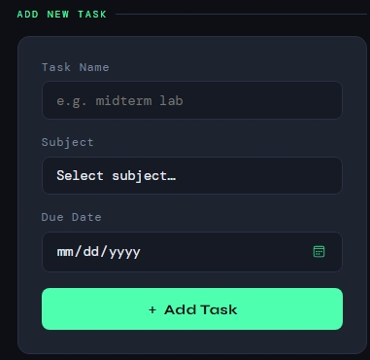

3.2 Task List Display
The right panel shows the task table with columns: #, Task Name, Subject, Due Date, Action. Subject values appear as color-coded pills (yellow for Math, green for CS, purple for Physics, red for English). Overdue dates are highlighted in red with a warning symbol.
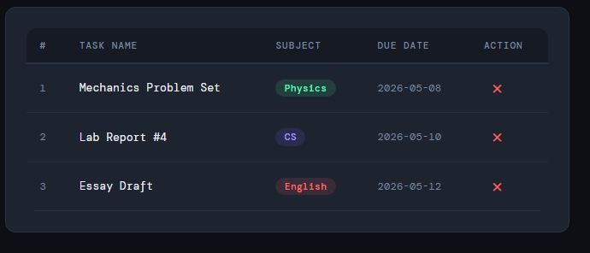

3.3 API Data Output
After clicking 'Fetch from API', the API section below the form displays five items fetched from JSONPlaceholder. Each card shows the item number, title (capitalized), user ID, and a status badge. A loading animation is visible while data is being fetched.
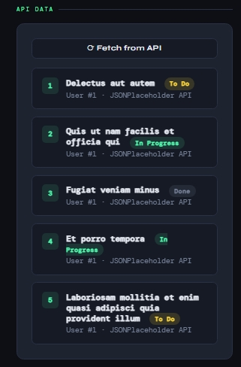

3.4 Filtering and Sorting
The controls bar above the task table shows two dropdowns: 'Filter by Subject' and 'Sort by Due Date'. When a subject is selected, only matching tasks are visible. When the sort order changes, the table is instantly re-ordered.
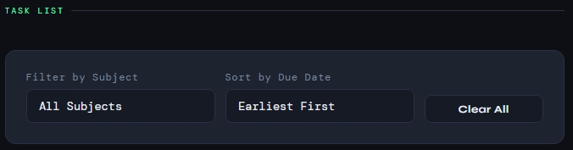

4. Conclusion
This lab gave me practical, hands-on experience building a complete, functional web application from scratch within a time-limited exam setting. The key takeaways are:
- Semantic HTML is essential for well-structured, accessible web pages. Using tags like <header>, <main>, <aside>, <section>, and <table> communicates meaning beyond just visual layout.
- CSS Flexbox and Grid together provide a powerful, flexible layout system. Media queries make it straightforward to adapt a desktop design for mobile devices without duplicating code.
- ES6 JavaScript features especially arrow functions, destructuring, spread operator, and template literals make code significantly shorter, more readable, and more expressive than older ES5 patterns.
- The Fetch API with async/await is the modern, clean way to integrate external data sources. Combined with proper error handling (try/catch), it creates a robust user experience even when the network fails.
- DOM manipulation inserting, updating, and removing HTML elements dynamically is what makes a static webpage come alive as a real application.
- Filtering and sorting data in-memory (on the client side) using array methods is fast, user-friendly, and requires no server round-trips.

Overall, this project reinforced how the three core web technologies HTML, CSS, and JavaScript work together as complementary layers: structure, presentation, and behaviour. The experience of integrating a live API further demonstrated how modern web applications consume and display data from external services, which is a foundational skill for full-stack web development.
